**INDEX**

**ACKNOWLEDGEMENT** 1

**ABSTRACT** 2

**LIST OF FIGURE** 3

**INTRODUCTION** 5

**AREA OF SPECIALIZATION** 6

**PROBLEM DEFINATION** 7

**PROPOSED METHODLOGY** 8

**DATA & METHODS** 9

**APPENDICES** 10

**Work breakdown** 13

# 

# **ACKNOWLEDGEMENT**

We Wish To Avail This Opportunity To Thank **Dr. Pranav Charkha Sir**, **Dean Of D.Y. Patil University School Of Engineering And Technology, Pune** For his Continuous Support And Giving Valuable suggestions During The Entire Period Of The Project Work.

We Take This Opportunity To Express Our Gratitude To **Prof. Malayaj Kumar, Head of The Department of Information Technology** for his Great Help And Encouragement to this Project Work.

We Would Like To Express Our Unbounded Gratefulness To Our Guide **Prof. Anurag jaiswal, Assistant Professor, Department Of Information Technology,** For her Valuable support And Motivation At Each And Every Point In Successful Completion Of The Project.

We Also Thank All The Faculty Of The **Department Of Information Technology And Engineering** for Their Help And Guidance On Numerous Occasions, Which Has Given Us The Cogency To Build-Up Adamant Aspiration Over The Completion Of Our Project Thesis.

Finally We Thank One And All Who Directly Or Indirectly Helped Us To Complete Our Project thesis Successfully.

# **ABSTRACT**

Promptify is a dynamic prompt sharing platform designed to facilitate creative inspiration and collaboration among users. The platform allows users to create, share, and explore prompts across various activities and projects. By harnessing the power of community-driven content creation, Promptify aims to break down creative barriers and foster a vibrant ecosystem of idea generation.

This project report provides an in-depth analysis of Promptify, detailing its objectives, key features, functionality, quality control measures, technology stack, user experience, monetization strategy (if applicable), marketing and growth strategy, challenges faced, and future enhancements.

Through this report, readers will gain insight into the development process, underlying technology, and potential impact of Promptify on the creative community. The abstract offers a concise overview of the project report, highlighting its significance and relevance in the context of digital collaboration and creative expression.

# **LIST OF FIGURE**

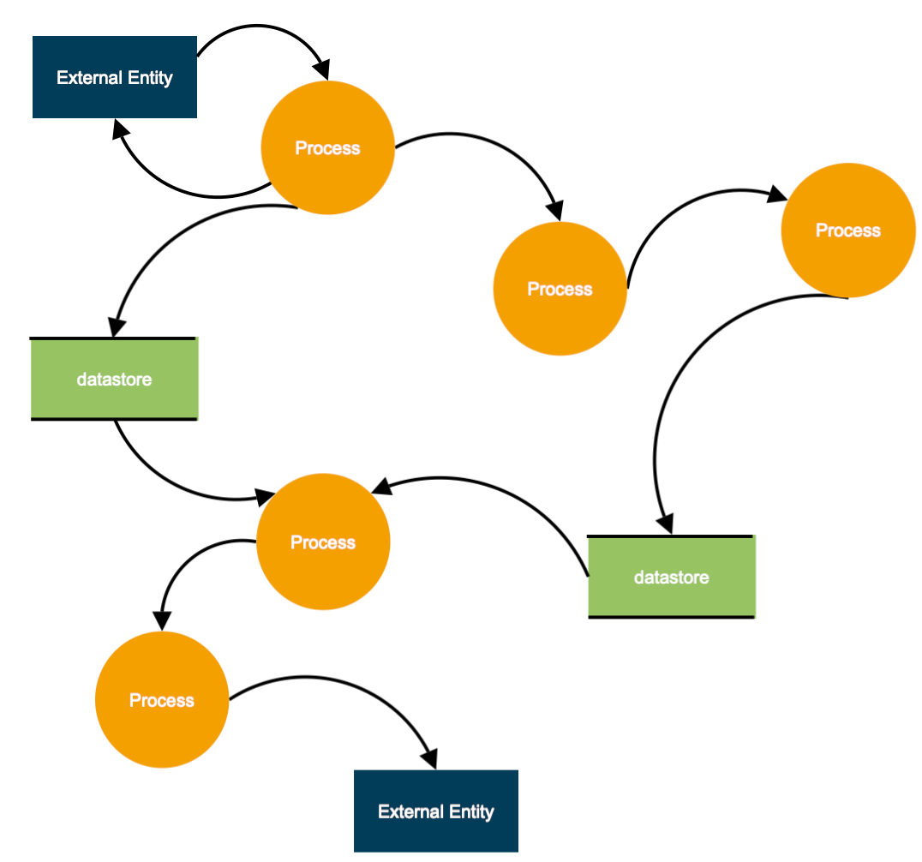

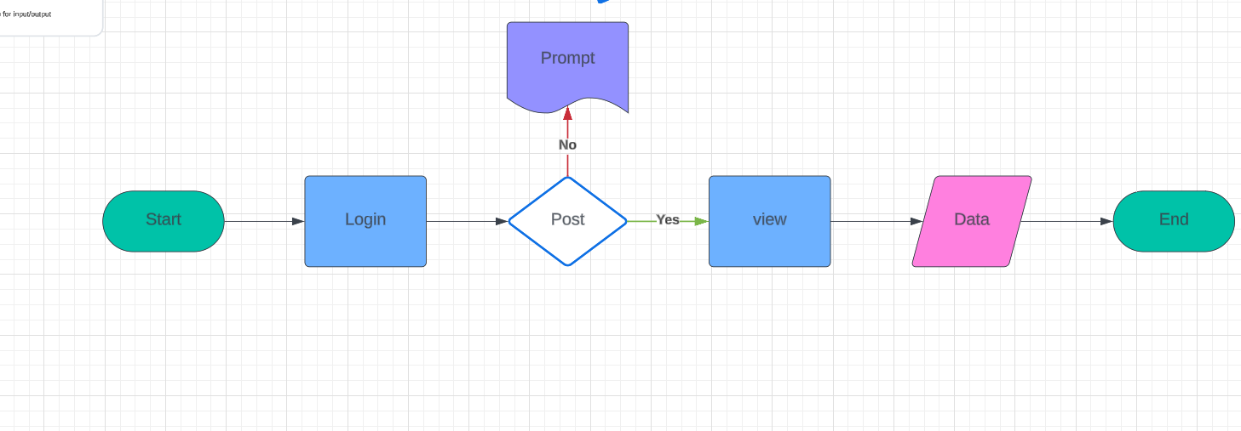

# **INTRODUCTION**

1. **Background:**

* Provide context on the increasing demand for platforms that facilitate creative collaboration and idea generation.
* Discuss the challenges individuals often face in finding inspiration and prompts for various activities and projects.

1. **Purpose of Promptify:**

* Clearly state the purpose of Promptify as a dynamic prompt sharing platform.
* Emphasize the goal of breaking down creative barriers and fostering collaboration among users.

1. **Overview of Promptify:**

* Briefly introduce Promptify as the ultimate prompt sharing platform.
* Highlight its key features and functionalities, such as prompt creation, sharing, and exploration.

1. **Significance of the Project:**

* Discuss the significance of Promptify in addressing the needs of creative individuals and communities.
* Highlight how Promptify contributes to promoting creativity, collaboration, and innovation.

# **AREA OF SPECIALIZATION**

1. **Target Audience:**

* Define the specific target audience that Promptify caters to. This could include writers, artists, educators, game developers, or any other creative individuals or groups.
* Discuss the unique needs and challenges faced by this audience in finding prompts and fostering creativity.

1. **Types of Prompts:**

* Describe the range of prompts supported by Promptify. This could include writing prompts, art prompts, brainstorming prompts, project prompts, or any other relevant types.
* Highlight the diversity of prompts available on the platform to appeal to a wide range of interests and creative endeavors.

1. **Community Engagement:**

* Emphasize the importance of community engagement within Promptify's specialization area.
* Discuss how Promptify fosters collaboration, feedback, and interaction among users within specific creative niches or communities.

1. **Quality Assurance:**

* Address how Promptify ensures the quality and relevance of prompts within its specialization area.
* Discuss any moderation or curation processes in place to maintain a high standard of content.

# **PROBLEM DEFINATION**

1. **Introduction to the Problem:**

* Start by introducing the broader context in which the problem exists. This could include the challenges faced by creative individuals in finding inspiration or overcoming creative blocks.

1. **Identifying the Pain Points:**

* Discuss the specific pain points experienced by the target audience. This could include:
* Difficulty in finding diverse and engaging prompts for creative activities.
* Lack of collaboration and feedback in the prompt-sharing process.
* Tedious and time-consuming process of generating prompts from scratch.

1. **Impact of the Problem:**

* Highlight the consequences of the identified pain points. This could include:
* Hindered creativity and productivity among individuals and communities.
* Frustration and demotivation leading to creative stagnation.
* Limited opportunities for collaboration and skill development.

1. **Existing Solutions and Limitations:**

* Briefly discuss existing solutions or alternatives available to address the problem. This could include:
* Manual prompt generation methods.
* Other prompt-sharing platforms or communities.
* Highlight the limitations or shortcomings of these existing solutions in fully addressing the identified pain points.

# **PROPOSED METHODLOGY**

**1. Objective Alignment:**

* Begin by revisiting the objectives of Promptify as outlined in the project report's introduction.
* Ensure that the proposed methodology aligns closely with these objectives to address the identified problem effectively.

2.**User Research and Needs Analysis:**

* Conduct thorough user research to gain insights into the needs, preferences, and pain points of the target audience.
* Utilize surveys, interviews, and user testing to gather qualitative and quantitative data.
* Analyze the research findings to identify key user requirements and inform the design and development process.

**3.Feature Prioritization and Road-mapping:**

* Prioritize features based on user research findings and the project objectives.
* Create a roadmap outlining the phased implementation of features, starting with essential functionalities and gradually expanding based on user feedback and iteration.

**4.Iterative Design and Development:**

* Adopt an iterative design and development approach to continually refine and improve Promptify.
* Start with prototyping and wireframing to visualize the user interface and user experience.
* Develop Minimum Viable Product (MVP) versions of Promptify to gather early feedback from users.
* Incorporate agile development methodologies to enable flexibility and responsiveness to changing requirements.

# **DATA & METHODS**

**1. Data Collection:**

* Describe the sources of data used in your project. This could include:
* User-generated content from Promptify platform.
* Survey responses from users or stakeholders.
* Interviews with target audience members or industry experts.
* Data from existing prompt-sharing platforms or repositories.
* Explain the process of collecting data, including any tools or platforms used for data collection.

**2.Data Types and Characteristics:**

* Classify the types of data collected (e.g., qualitative, quantitative) and their characteristics.
* Discuss the relevance of each type of data to your research objectives and analysis.

**3.Sampling Methodology :**

* If you conducted surveys or interviews, explain your sampling methodology.
* Describe how participants were selected and recruited for data collection.
* Justify your sampling approach based on the target audience and research objectives.
* Data Analysis Methods:

**4.Outline the methods used to analyze the collected data. This could include:**

* Qualitative analysis techniques such as thematic analysis, content analysis, or grounded theory.
* Quantitative analysis methods such as descriptive statistics, regression analysis, or factor analysis.
* Mixed methods approaches combining qualitative and quantitative analysis.
* Explain how each method was applied to extract insights and draw conclusions from the data.

# **APPENDICES**

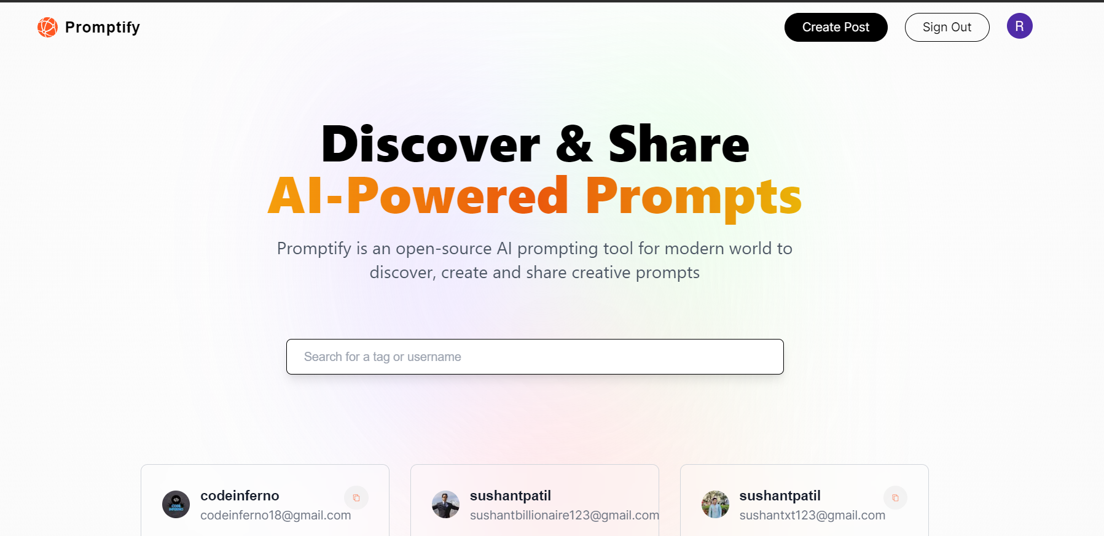

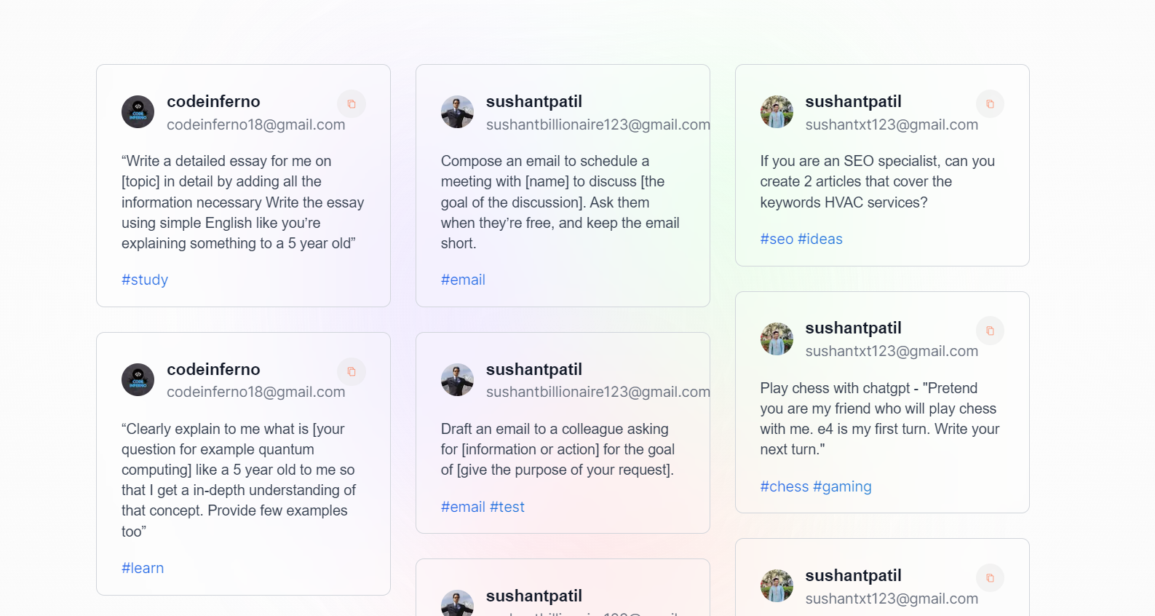

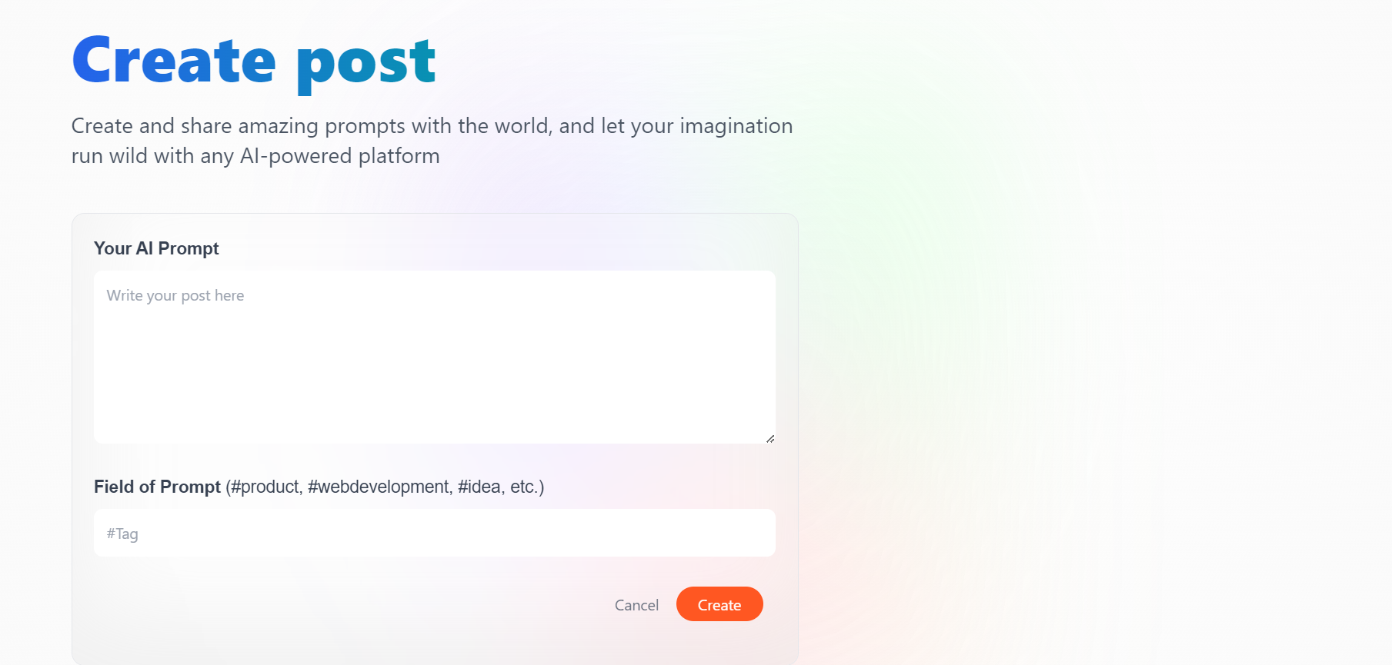

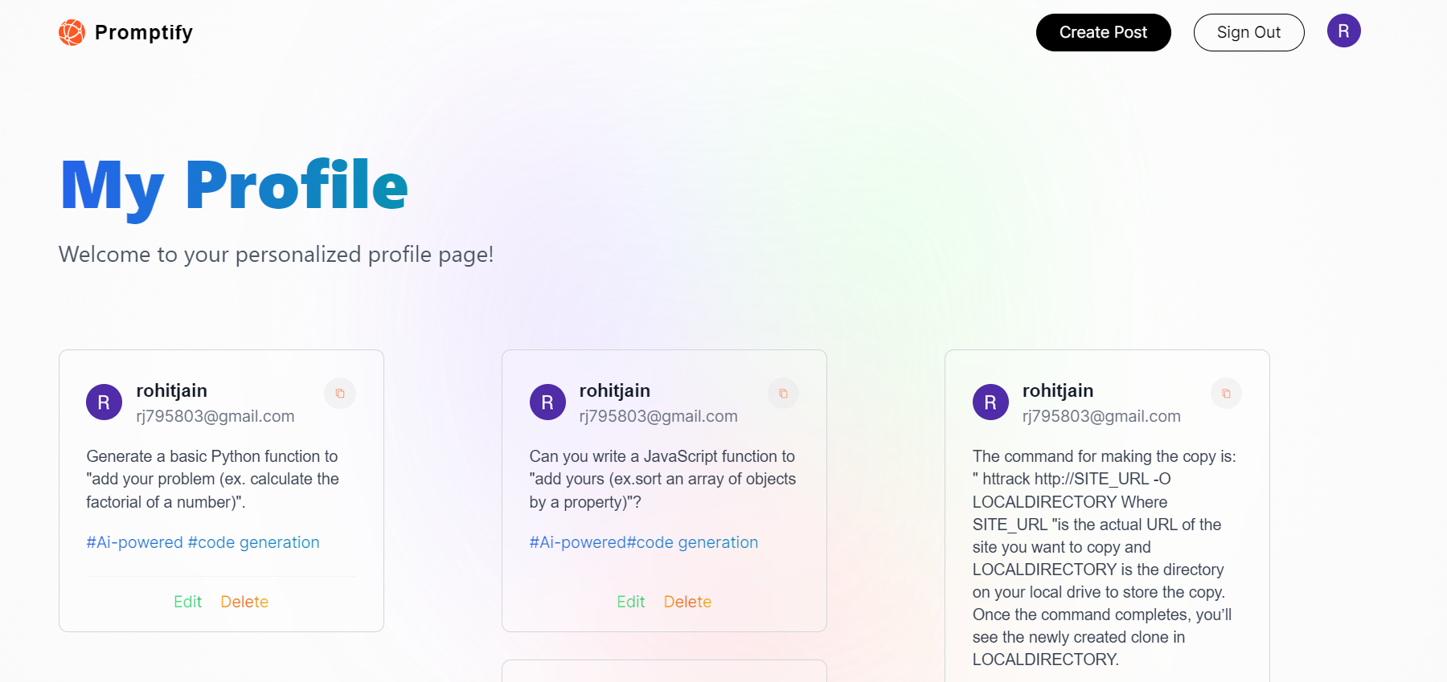

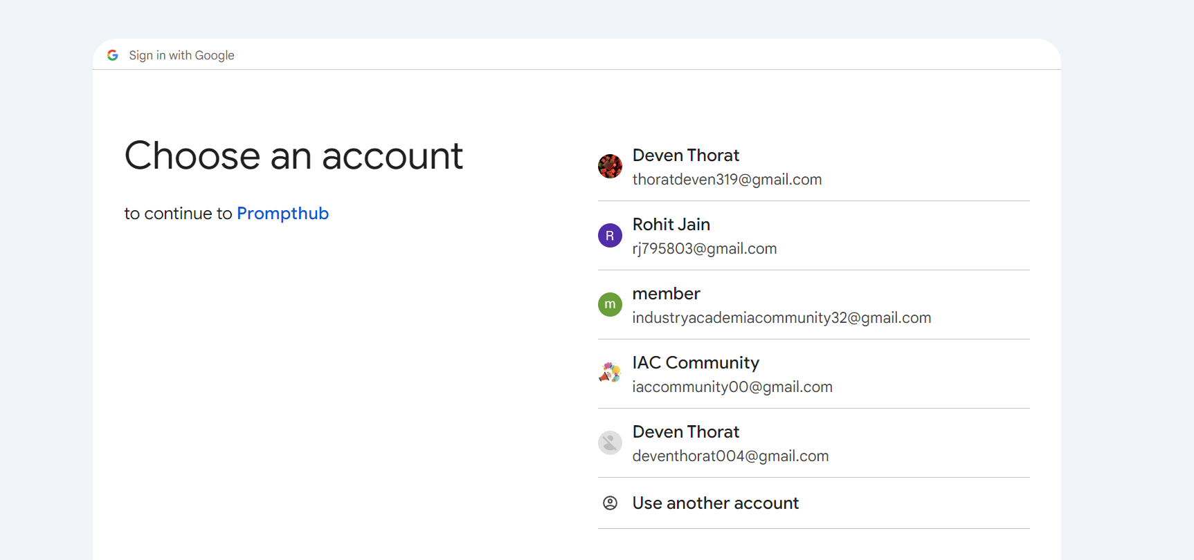

# **Work breakdown**

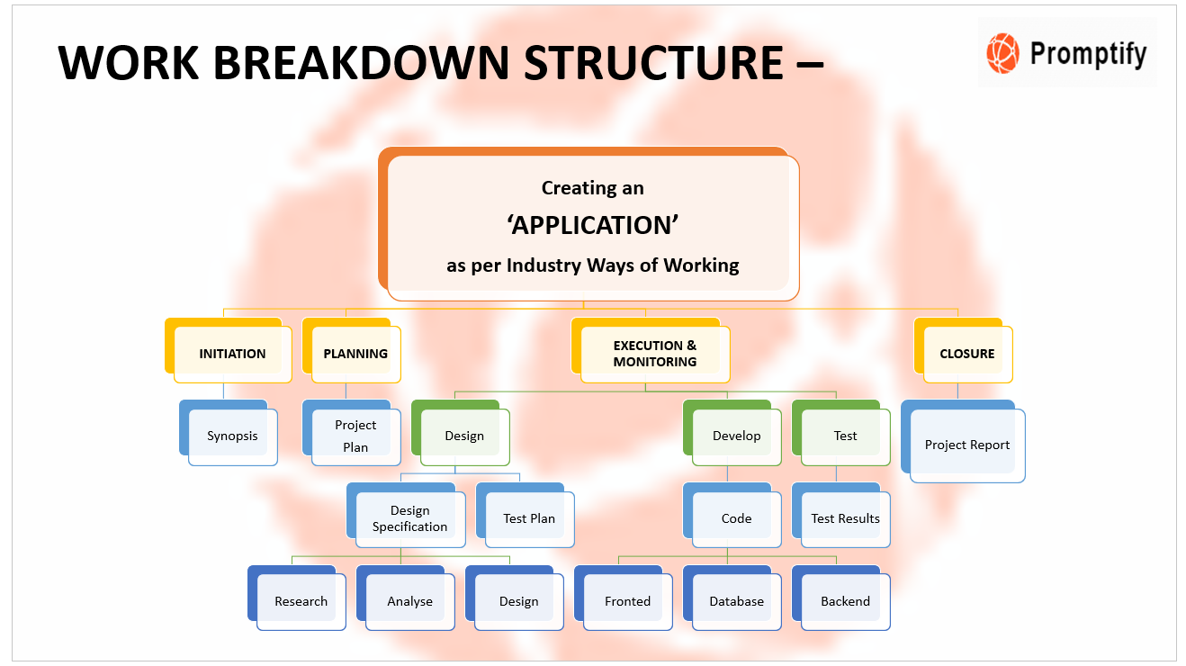

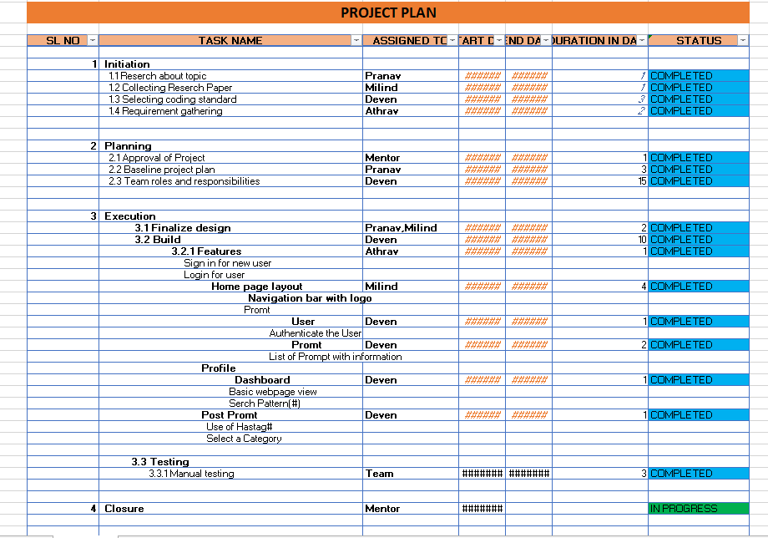

**CONCLUSION**

Promptify is a dynamic prompt-sharing platform designed to address the challenges faced by creative individuals in finding inspiration and fostering collaboration. Through Promptify, users can create, share, and explore prompts across various activities and projects. The platform leverages community-driven content creation to break down creative barriers and promote innovation. By prioritizing user engagement, feedback, and continuous improvement, Promptify aims to empower individuals and communities to unleash their creativity and realize their full potential. With its user-centric approach and commitment to fostering a vibrant ecosystem of idea generation, Promptify stands as a testament to the power of collaboration in driving creative expression and innovation forward. Through user engagement, feedback mechanisms, and continuous improvement, Promptify empowers users to overcome creative blocks and unleash their full creative potential. With its user-centric design and commitment to fostering a vibrant ecosystem of idea generation, Promptify is poised to make a significant impact in the creative community, inspiring innovation and collaboration on a global scale.

**Reference**

Promptify. (2024). Title of the platform (1.0.0) [Online platform]. Vercel or https://promptify-bi14-nextjs.vercel.app/

For example:

Promptify. (2024). Promptify: The Ultimate Prompt Sharing Platform [Vercel]. Retrieved from https://promptify-bi14-nextjs.vercel.app/

Make sure to replace "2024" with the actual year the platform was launched or made available to the public. If there's a specific version number for Promptify, include it in parentheses after the platform's title. If Promptify was published or hosted by a specific organization or publisher, include their name in the reference. If it's available online, provide the URL where Promptify can be accessed.

If you have other specific references related to Promptify's development, such as research papers, articles, or documentation, you can include them in the reference list following the appropriate citation style (e.g., APA, MLA, Chicago). Let me know if you need assistance with formatting additional references!